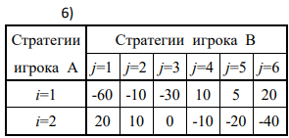

|  |  |  |
| --- | --- | --- |
| Стратегия игрока В | Стратегия игрока А | |
| 1 | 2 |
| 1 | -60 | 20 |
| 2 | -10 | 10 |
| 3 | -30 | 0 |
| 4 | 10 | -10 |
| 5 | 5 | -20 |
| 6 | 20 | -40 |

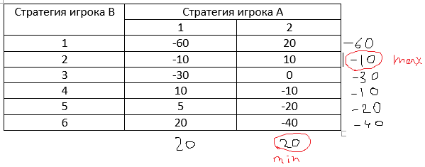

-10 – нижняя цена игры

20 – верхняя цена игры

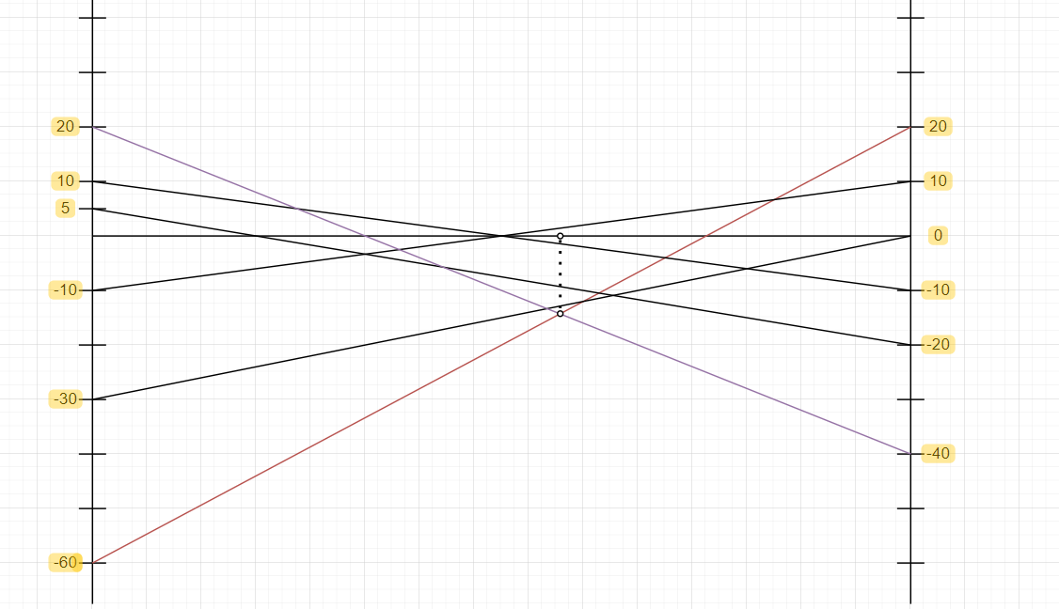

$$\left\{\begin{aligned}\left(-40-20\right)p1+20=0 \\ \left(-20+60\right)p1-60=0\end{aligned}\right.$$

p1 = 0.8

p2 = 1-p1 = 0.2

-60p2 + 20 = 8 – цена игры

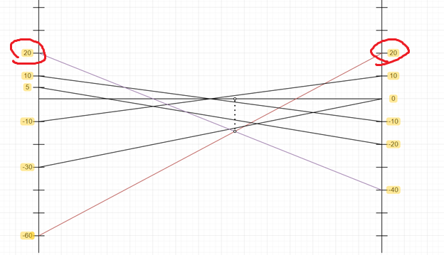

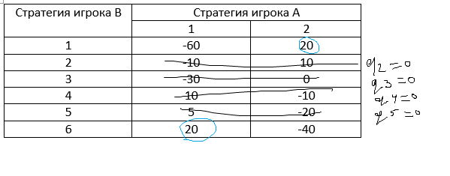

$$\left\{\begin{aligned}-60q1+20q6=8 \\ 20q1-40q6=8 \\ q1+q6=1\end{aligned}\right.$$

q1 = 1-0.2 = 0.8

q6 = 0.2

Через линейное программирование:

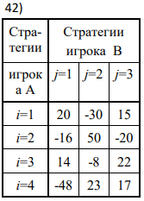

|  |  |  |  |  |
| --- | --- | --- | --- | --- |
|  | **С1** | **С2** | **С3** | **p** |
| **S1** | **20** | **-30** | **15** | **p1** |
| **S2** | **-16** | **50** | **-20** | **p2** |
| **S3** | **14** | **-8** | **22** | **p3** |
| **S4** | **-48** | **23** | **17** | **p4** |
| **q** | **q1** | **q2** | **q3** |  |

W(P*,С1) = 20*p1 - 16*p2 + 14*p3 - 48*p4 >= V x4 = p4/xxxxxxограммирование

W(P*,С2) = -30*p1 + 50*p2 - 8*p3 + 23*p4 >= V

W(P*,С3) = 15*p1 - 20*p2 + 22*p3 + 17*p4 >= V

p1 >= 0, p2 >= 0, p3 >= 0, p4 >= 0

p1 + p2 + p3 + p4 = 1

x1 = p1/V; x2 = p2/V; x3 = p3/V; x4 = p4/V

W(P*,С1) = 20*x1 - 16*x2 + 14*x3 - 48*x4 >= 1 x4 = p4/xxxxxxограммирование

W(P*,С2) = -30*x1 + 50*x2 - 8*x3 + 23*x4 >= 1

W(P*,С3) = 15*x1 - 20*x2 + 22*x3 + 17*x4 >= 1

x1 >= 0, x2 >= 0, x3 >= 0, x4 >= 0

x1 + x2 + x3 + x4 = 1/V -> min(x1,x2,x3,x4)

W(S1,Q*) = 20*q1 – 30*q2 + 15*q3 <= V

W(S2,Q*) = -16*q1 + 50*q2 - 20*q3 <= V

W(S3,Q*) = 14*q1 – 8*q2 + 22*q3 <= V

W(S4,Q*) = -48*q1 + 23*q2 + 17*q3 <= V

q1 >= 0, q2 >= 0, q3 >= 0

q1 + q2 + q3 = 1

y1 = q1/V; y2 = q2/V; y3 = q3/V

W(S1,Q*) = 20*y1 – 30*y2 + 15*y3 <= 1

W(S2,Q*) = -16*y1 + 50*y2 - 20*y3 <= 1

W(S3,Q*) = 14*y1 – 8*y2 + 22*y3 <= 1

W(S4,Q*) = -48*y1 + 23*y2 + 17*y3 <= 1

y1 >= 0, y2 >= 0, y3 >= 0

y1 + y2 + y3 = 1/V -> max(y1,y2,y3)